EXPERIMENT 12
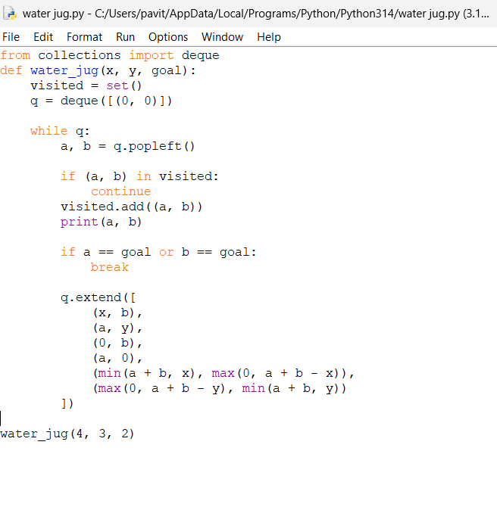
OUTPUT
